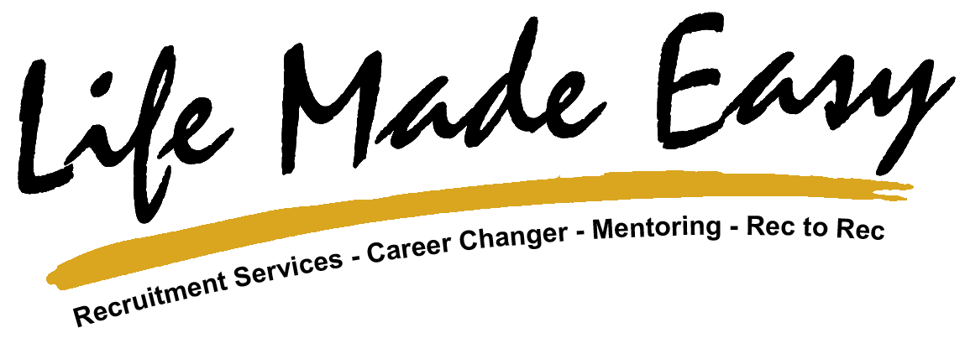

- Make sure that you customise your Public Profile URL.
- Have a professional photo taken, head and shoulders only.
- Upload a cover image that is professional and a reflection of you.
- Incorporate relevant keywords into your headline statement.
- Have a clear & concise summary that reflects your working career and also something about you personally.
- Make sure that your profile experience is complete with dates, names and no gaps in the timeline.
- Ensure that your personal information is complete, e.g. email address, website, blog and other platforms, mobile or contact phone numbers.
- If you have other online platforms, make sure that the “visual” brand presence is in line with these.
- Strive to get at least 8 - 10 third party recommendations on your profile as fast as you can.
- Connect with as many relevant connections that you can so that you get to 1000 connections quickly.

